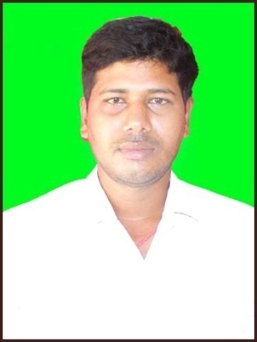**CURRICULUM VITAE**

**Name** : Nihar Ranjan Behera

**Address**: At- Paikapada Patna,

Po/PS- Narsinghpur,

Dist- Cuttack,

Pin- 754032,

E mail : nihar.behera09@gmail.com

**Mob No**: 9861585782,6372376594

#### Career Objective:

. I am in quest of a challenging position in an organization that will allow me to utilize my knowledge, professional acumen, responsibility and sincerity to its full degree. I would also like to afford full scope to plan, implement and apply my knowledge, experience and common sense for the growth of both the company and self on a win-win strategy.

EDUCATION PROFILE

Professional Qualification:

Diploma : DCAM

Discipline : DOS,WINDOWS 98/XP,MS-Office,Tally.

Percentage : 70%

Institution : IICSM

Year of passing : 2008.

Academic Qualification:

Course :10th

Percentage :45%

Institution : A.N.High School.

Board : B.S.E. Odisha,

Year of passing : 2001.

Course :+2 Arts

Percentage :40%

Institution :Narsinghpur College.Narsinghpur.

Board :C.H.S.E,Odisha.

Year of passing :2003.

Course :+3Arts

Percentage :43%

Institution :Narsinghpur college,Narsinghpur.

Board :Utkal University,Bhubaneswar.

Year of passing :2006.

KEY STRENGTH

1. Target oriented
2. Hardworking
3. Sincere

EXPERIENCE

1-Working as a computer operater in furniture associate.

2- 5Years work in Finopayments Bank as a field operator.

1-Account oppening.

2-Merchant onboarding.

3-Gold loan.

4-Payment disbursement.

5-continue as sales manager in Veritas finance Pvt ltd.

PERSONAL INFORMATION

Date Of Birth :11-06-1985.

Father’s Name :Late Trilochan Behera.

Sex :Male.

Nationality :Indian

Language Proficiency :English,Hindi,Oriya,

Marital Statous. :Married.

DECLARATION:

I do hereby declare that the information furnished above is true to best my knowledge and belief.

Sri Nihar Ranjan Behera

Signature

Dat:17-10-2020

Place:Narsinghpur